In LAB: implement ripple-carry adder in Verilog and program it on the FPGA board

Step 1. Half Adder (code):

`timescale 1ns / 1ps

//////////////////////////////////////////////////////////////////////////////////

// Company:

// Engineer:

//

// Create Date: 19:24:22 04/24/2018

// Design Name:

// Module Name: HalfAdder

// Project Name:

// Target Devices:

// Tool versions:

// Description:

//

// Dependencies:

//

// Revision:

// Revision 0.01 - File Created

// Additional Comments:

//

//////////////////////////////////////////////////////////////////////////////////

module HalfAdder(

input a,

input b,

output sum,

output cout

);

xor(sum, a, b);

and(cout, a, b);

endmodule

Step 2. Full Adder (code):

Full Adder

`timescale 1ns / 1ps

//////////////////////////////////////////////////////////////////////////////////

// Company:

// Engineer:

//

// Create Date: 19:25:24 04/24/2018

// Design Name:

// Module Name: FullAdder

// Project Name:

// Target Devices:

// Tool versions:

// Description:

//

// Dependencies:

//

// Revision:

// Revision 0.01 - File Created

// Additional Comments:

//

//////////////////////////////////////////////////////////////////////////////////

module FullAdder(

input a,

input b,

input cin,

output sum,

output cout

);

wire c1, c2, s;

HalfAdder T1(.a(a), .b(b), .sum(s), .cout(c1));

HalfAdder T2(.a(cin), .b(s), .sum(sum), .cout(c2));

or(cout, c1, c2);

endmodule

Step 3. Ripple-Carry Adder (code):

`timescale 1ns / 1ps

//////////////////////////////////////////////////////////////////////////////////

// Company:

// Engineer:

//

// Create Date: 19:30:26 04/24/2018

// Design Name:

// Module Name: RippleCarryAdder

// Project Name:

// Target Devices:

// Tool versions:

// Description:

//

// Dependencies:

//

// Revision:

// Revision 0.01 - File Created

// Additional Comments:

//

//////////////////////////////////////////////////////////////////////////////////

module RippleCarryAdder(

input [1:0] a,

input [1:0] b,

input c0,

output [1:0] s,

output c2

);

wire c1;

FullAdder T1(.a(a[0]), .b(b[0]), .cin(c0), .sum(s[0]), .cout(c1));

FullAdder T2(.a(a[1]), .b(b[1]), .cin(c1), .sum(s[1]), .cout(c2));

endmodule

Result:

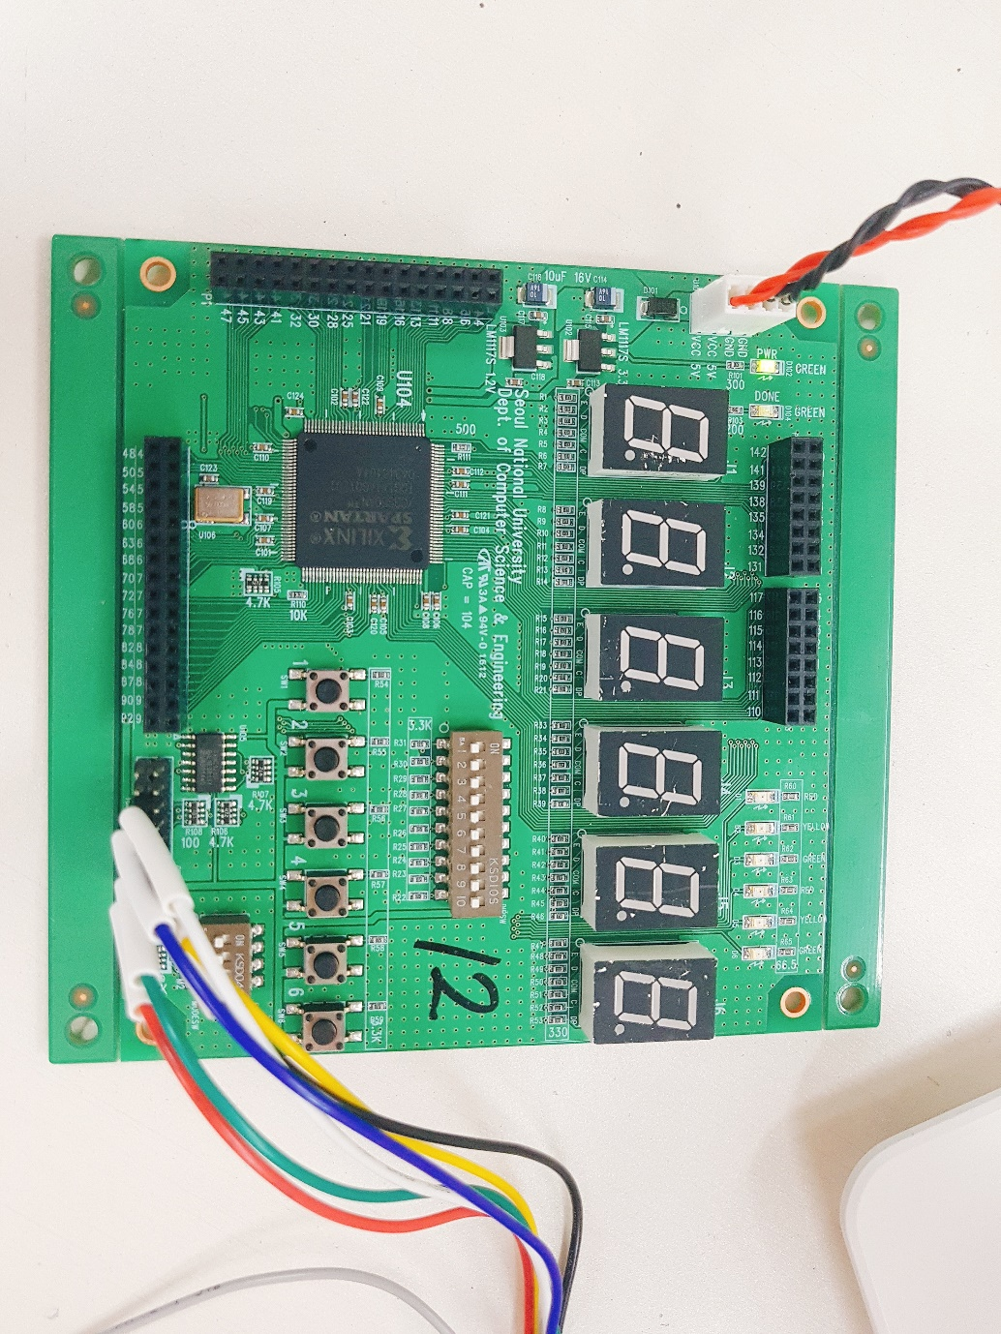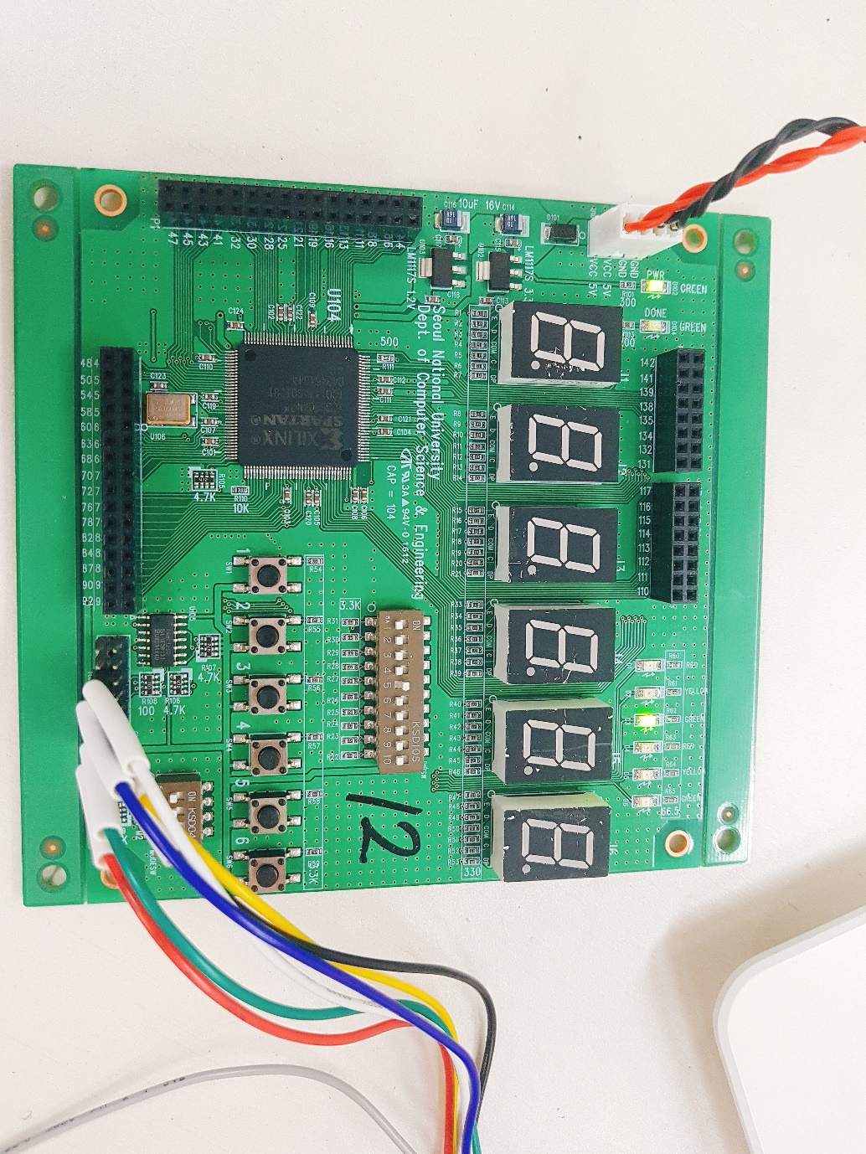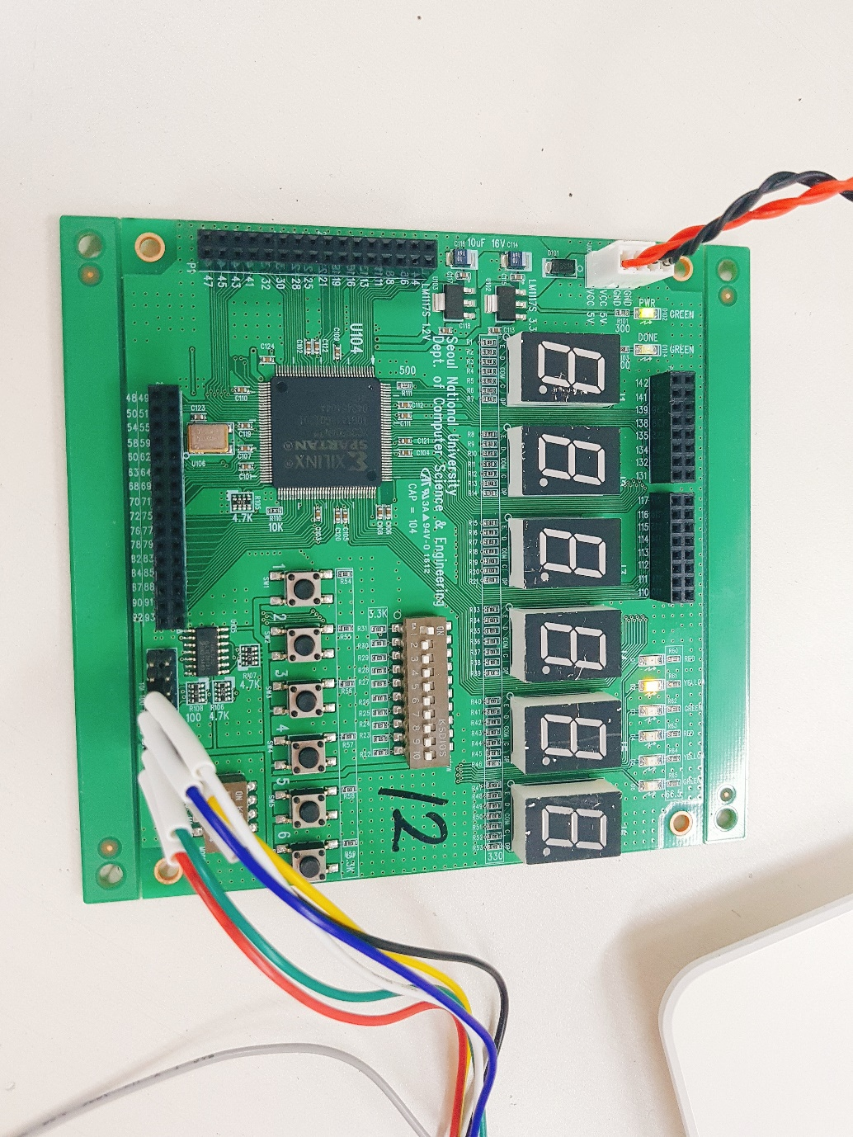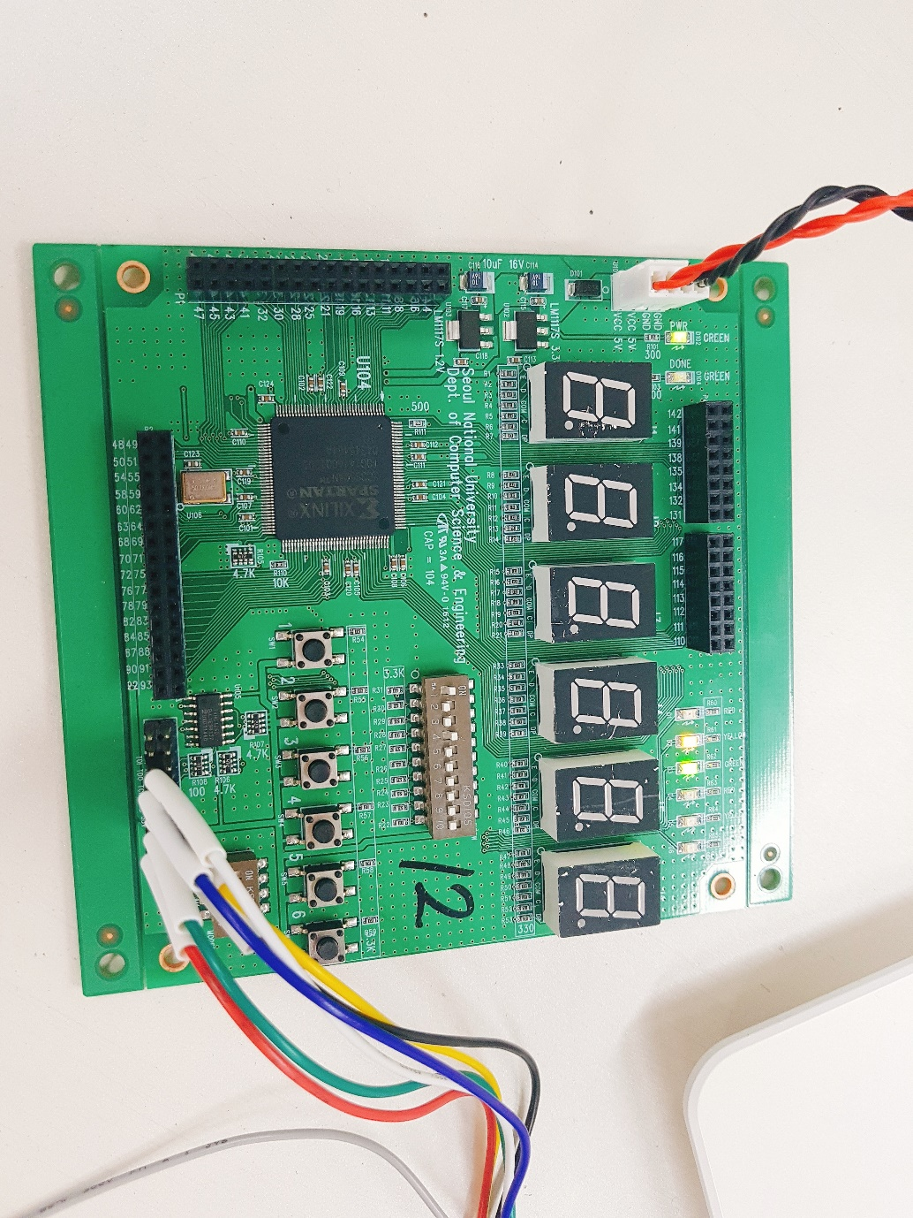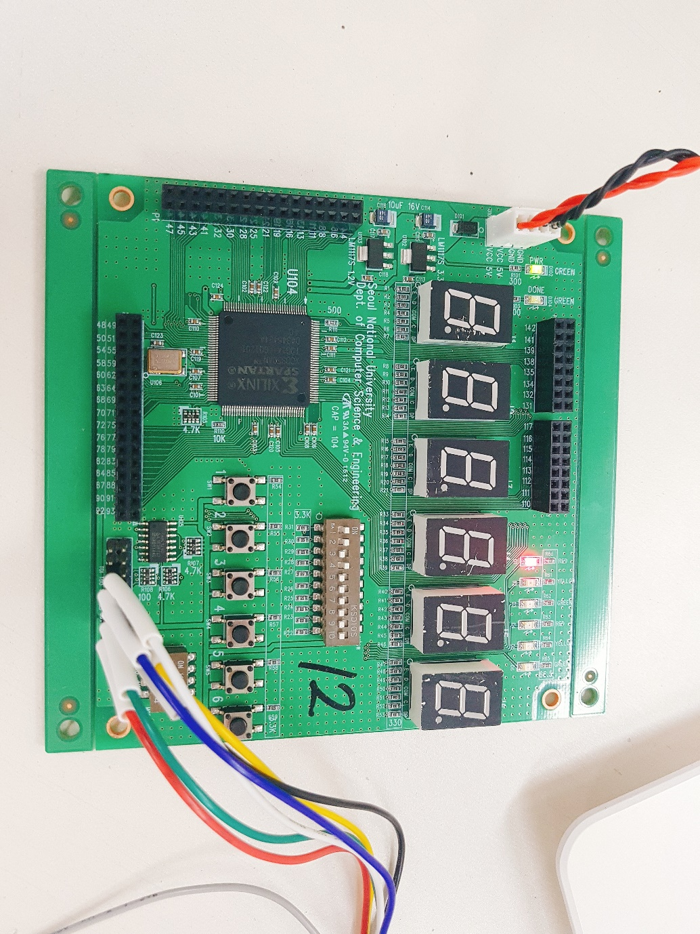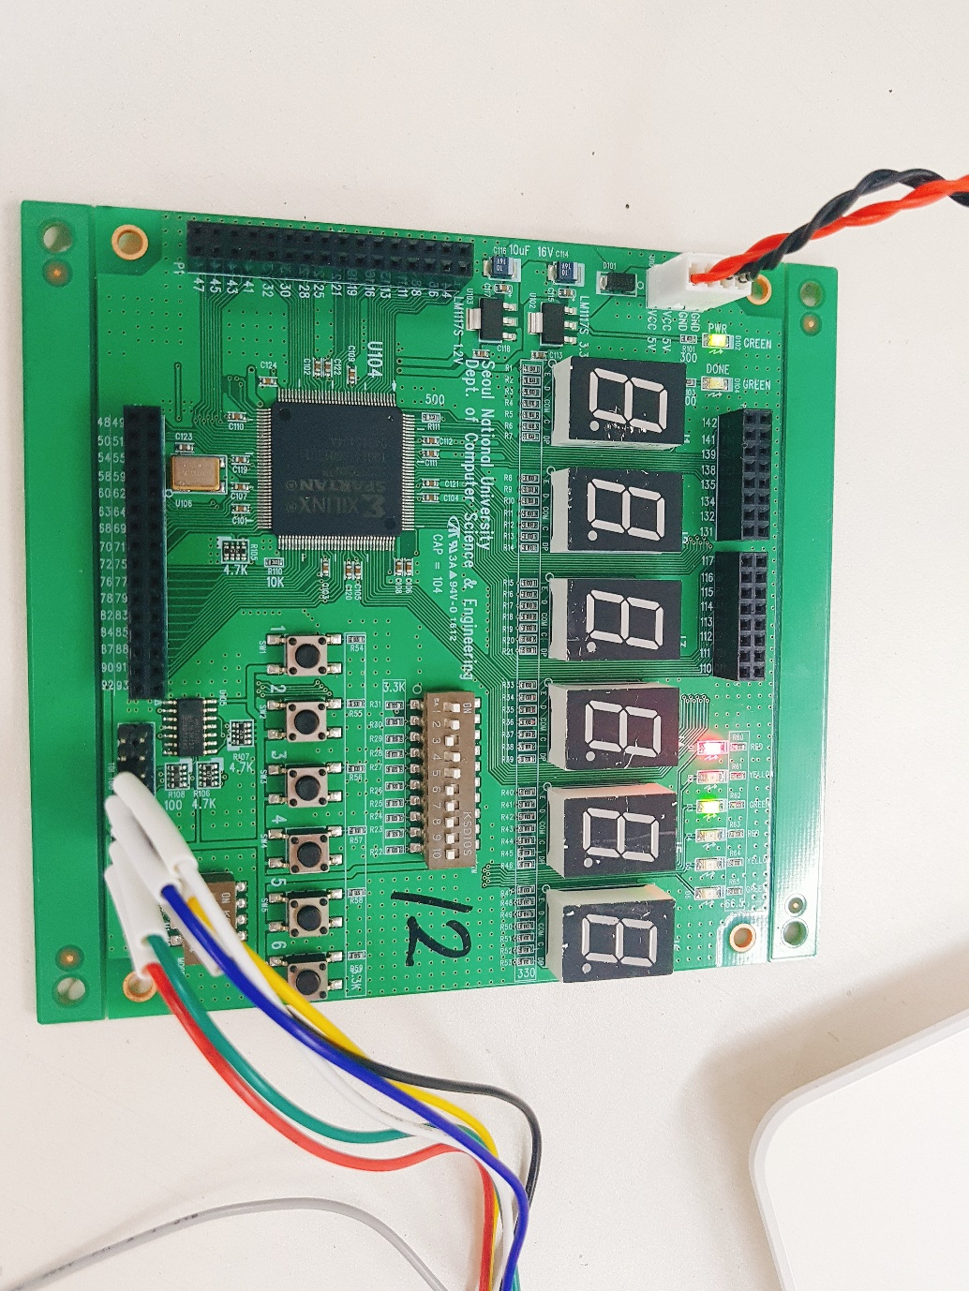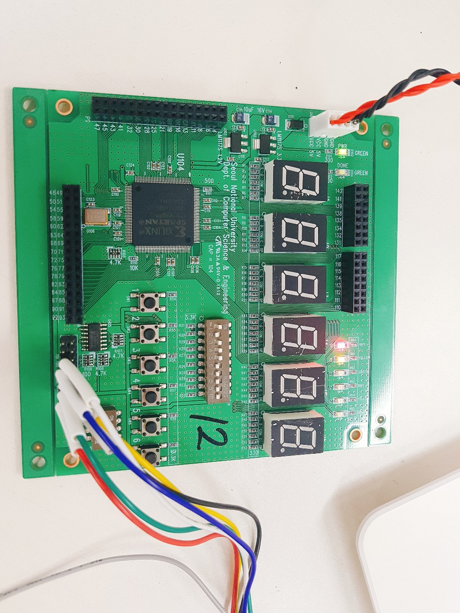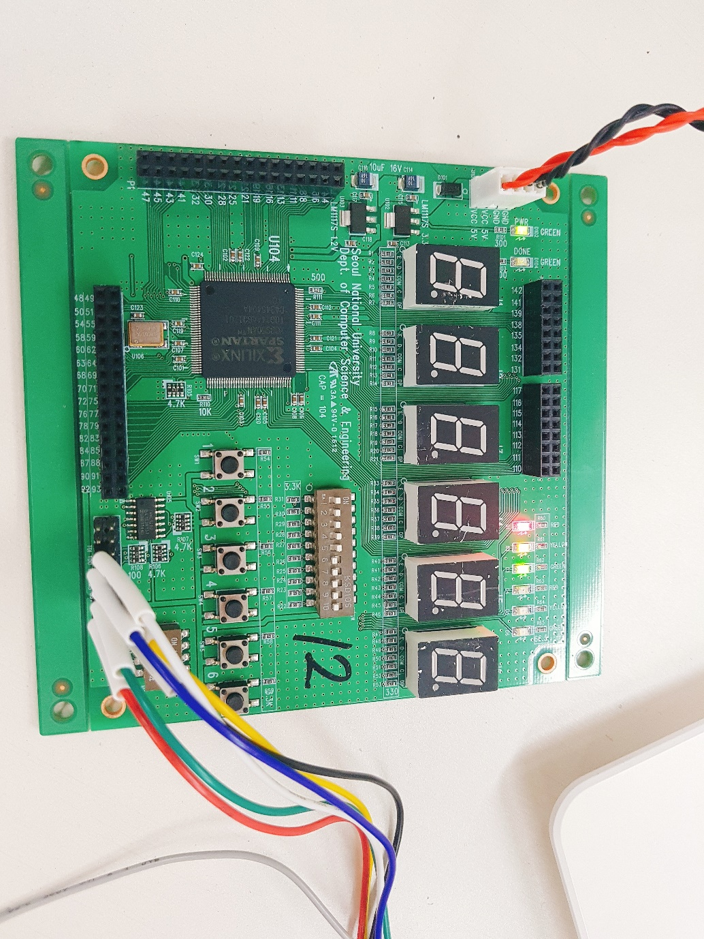

Homework: implement 1-bit Arithmetic Logic Unit (ALU) in Verilog and simulate all possible outputs using Verilog test bench.

1-bit ALU (code):

`timescale 1ns / 1ps

//////////////////////////////////////////////////////////////////////////////////

// Company:

// Engineer:

//

// Create Date: 19:45:04 04/24/2018

// Design Name:

// Module Name: OneBitALU

// Project Name:

// Target Devices:

// Tool versions:

// Description:

//

// Dependencies:

//

// Revision:

// Revision 0.01 - File Created

// Additional Comments:

//

//////////////////////////////////////////////////////////////////////////////////

module OneBitALU(

input m,

input [1:0] s,

input a,

input b,

output f

);

reg out;

assign sel = {m, s[0]};

assign f = out;

always@(m or s or a or b)

begin

if(s[1]==1'b0)

begin

case(s[0])

1'b0 : out = a;

1'b1 : out = !a;

endcase

end

else

begin

case(sel)

2'b00 : out = (!a & b) | (!b & a);

2'b01 : out = !((!a & b) | (!b & a));

2'b00 : out = a | b;

2'b00 : out = (!a) | b;

endcase

end

end

endmodule

Result:

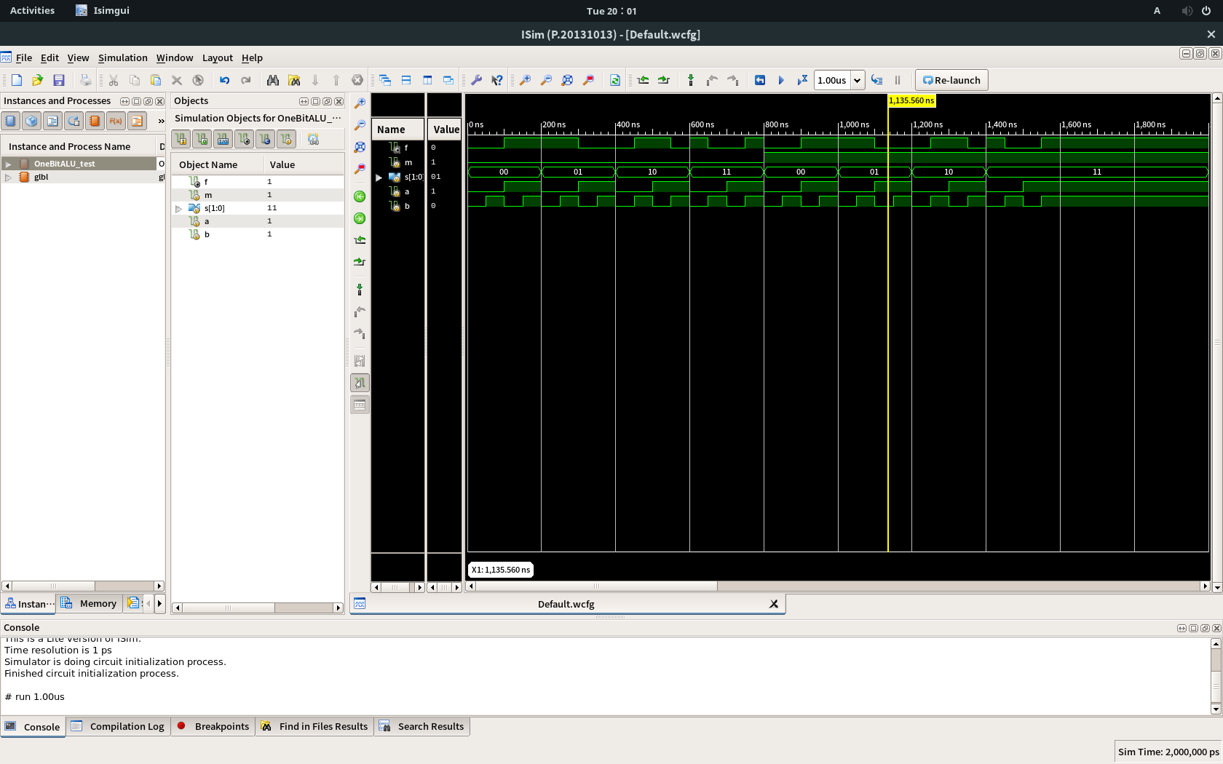

Test code for 1-bit ALU:

`timescale 1ns / 1ps

////////////////////////////////////////////////////////////////////////////////

// Company:

// Engineer:

//

// Create Date: 19:57:06 04/24/2018

// Design Name: OneBitALU

// Module Name: /csehome/ld15/OneBitALU/OneBitALU_test.v

// Project Name: OneBitALU

// Target Device:

// Tool versions:

// Description:

//

// Verilog Test Fixture created by ISE for module: OneBitALU

//

// Dependencies:

//

// Revision:

// Revision 0.01 - File Created

// Additional Comments:

//

////////////////////////////////////////////////////////////////////////////////

module OneBitALU_test;

// Inputs

reg m;

reg [1:0] s;

reg a;

reg b;

// Outputs

wire f;

// Instantiate the Unit Under Test (UUT)

OneBitALU uut (

.m(m),

.s(s),

.a(a),

.b(b),

.f(f)

);

initial begin

// Initialize Inputs

m = 0; s = 0; a = 0; b = 0; #50;

b = 1; #50;

a = 1; b = 0; #50;

b = 1; #50;

s = 1; a = 0; b = 0; #50;

b = 1; #50;

a = 1; b = 0; #50;

b = 1; #50;

s = 2; a = 0; b = 0; #50;

b = 1; #50;

a = 1; b = 0; #50;

b = 1; #50;

s = 3; a = 0; b = 0; #50;

b = 1; #50;

a = 1; b = 0; #50;

b = 1; #50;

m = 1; s = 0; a = 0; b = 0; #50;

b = 1; #50;

a = 1; b = 0; #50;

b = 1; #50;

s = 1; a = 0; b = 0; #50;

b = 1; #50;

a = 1; b = 0; #50;

b = 1; #50;

s = 2; a = 0; b = 0; #50;

b = 1; #50;

a = 1; b = 0; #50;

b = 1; #50;

s = 3; a = 0; b = 0; #50;

b = 1; #50;

a = 1; b = 0; #50;

b = 1; #50;

end

endmodule